**ALAGAPPA COLLEGE OF TECHNOLOGY**

**ANNA UNIVERSITY-600025**

**Project type:**

Instagram Reel: Create an Instagram reel for your business brand and promote it attract a minimum of 100 Likes

**Project name:**

Digital Marketing – Instagram reel

**Department:**

BTech-Food Technology

**Team Details:**

|  |  |  |
| --- | --- | --- |
| Name | Registration number | Naan-Mudhalvan Id |
| Vaishnavi Vaddiparthi | 2020304029 | 0A2DA712C90C5D784E54548E39F8CE86 |
| Kaarthick K | 2020304008 | 86DAC279D58557289214A356DF95332E |
| Hemasri S | 2020304007 | FDBA8EE99D339C892D74EFA1824B5CDB |
| Shivanesh S | 2020304024 | 7F69A28D9198F8ABEBF41035AFAB78DD |

**Brand Name:** JetSet Journeys

**Instagram Id :**jetsetjourneys.go

**Category:**Travel and Tourism

**Target Audience:** Insta Users

**E-mail:**jetsetjourneys.go@gmail.com

**File Upload** - Instagram Reel Video

**Insta link:** https://www.instagram.com/reel/Cy2_3_RLTRo/?igshid=MTc4MmM1YmI2Ng==

Upload in Instagram Business Profile and Share the links.

**INSTAGRAM REEL**

**Aim :** To create a instagram reel for your brand and publish it and get at least 100 likes

**Overview :**We created a Tourism site for Hodophiles and we had published the

promo video in instagram

**Purpose :** A travel agent can handle Unexpected.The main purpose of Jetset Journeys is to address the following. We provide

* Customized services
* Cost-effective and time-saving options
* Knowledge of proper documents
* Support for the local economy
* Ground support and vital connections

**Procedure:**

* create a instagram account
* Make it as a public and converted it into professional account
* uploaded the video in reels section
* view the insights and note it in results

**Result :** successfully reached more than 100+ likes from the society with in short time

**MAP:**

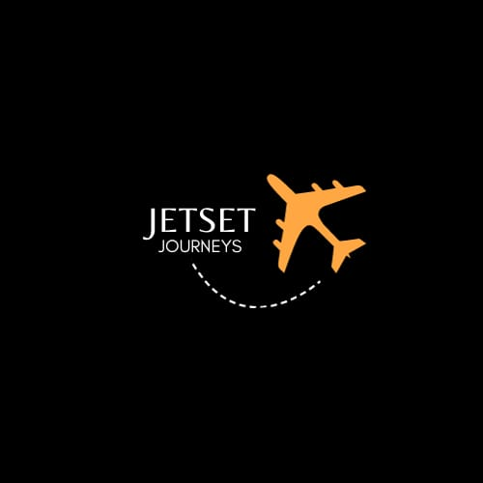

A Logo was first designed for travel agency using Canva

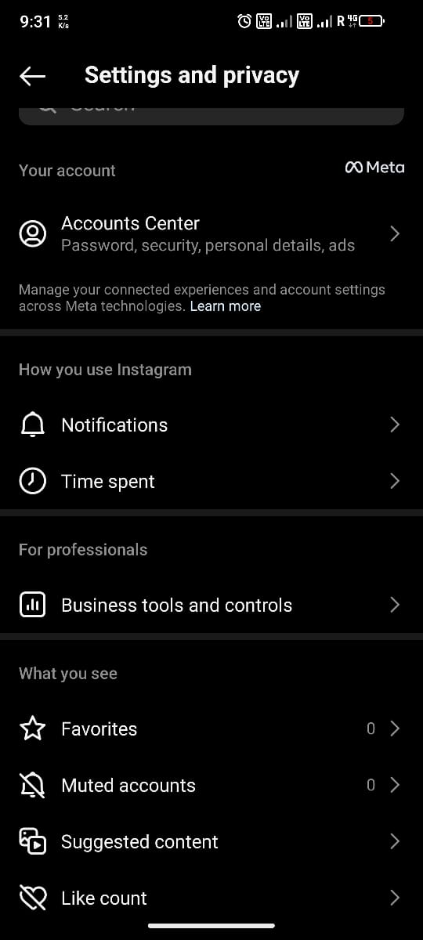 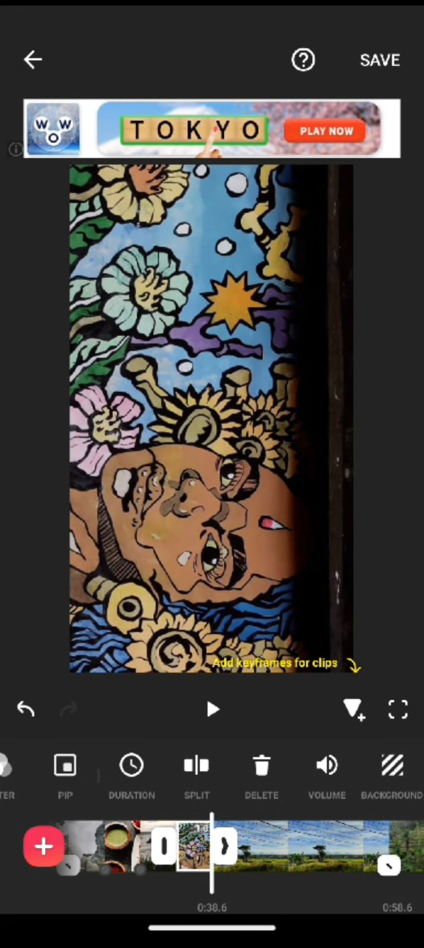

A sample video covering places,accomodation,fare for entire 3 day plan for BALI was explained in the promo video made

Insta account was created and was made public and

Professional account for our travel business.

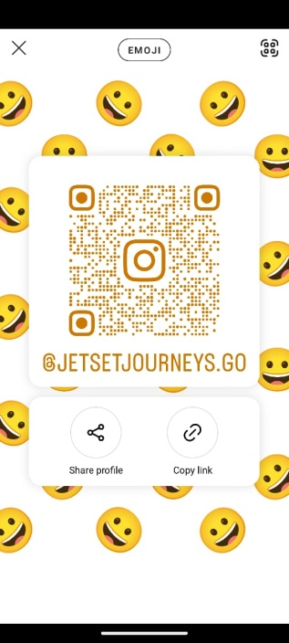QR code for efficient access of our insta page

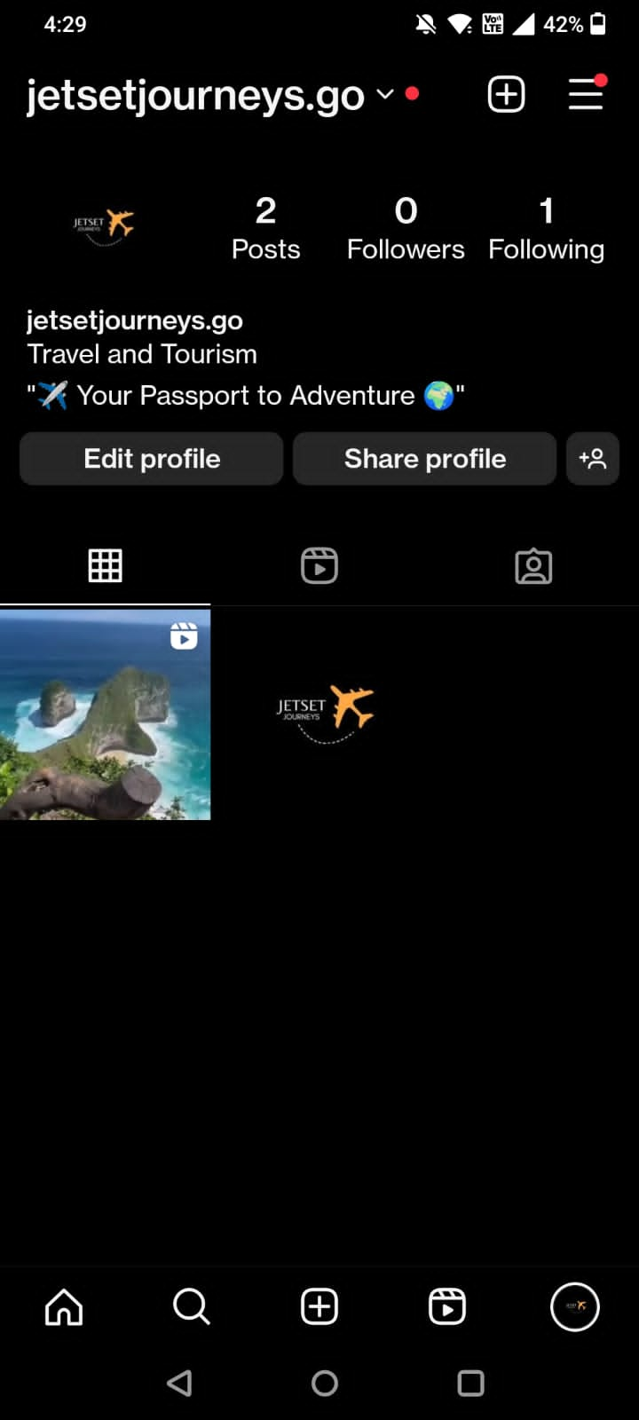 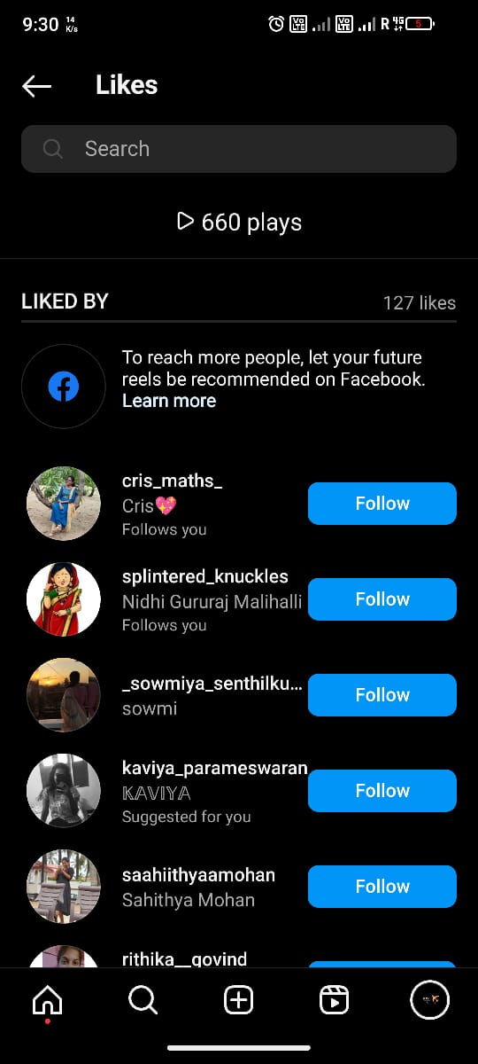

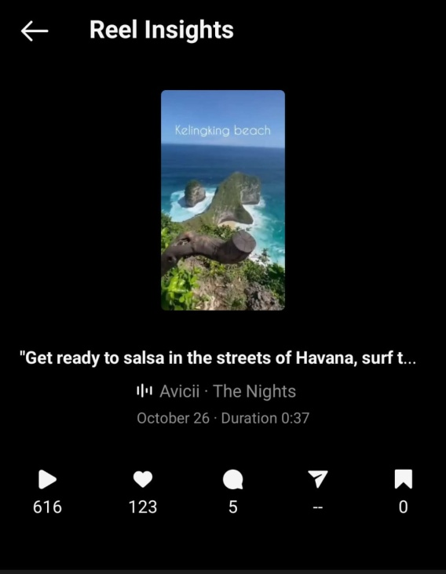

The posted video was played, liked, shared and saved by viewers.

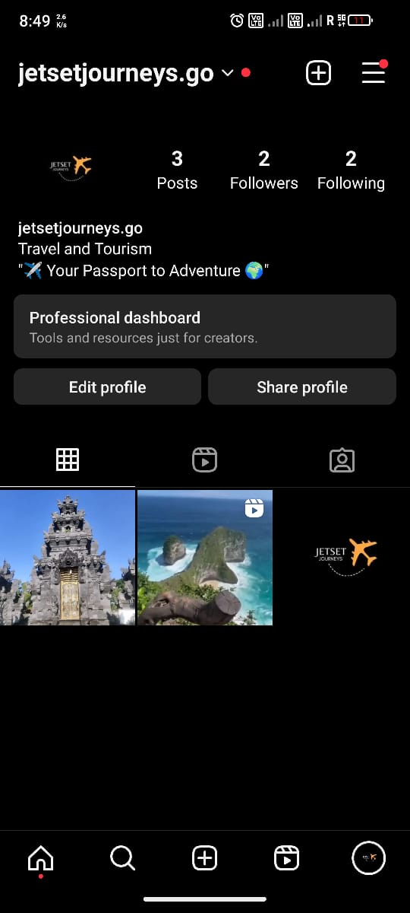 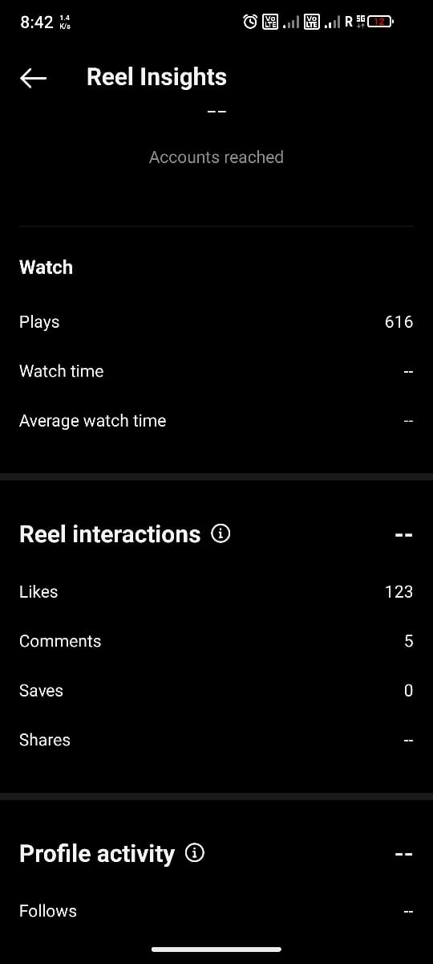

The entire page of Jetset Journeys and the reel insights.